

**ARCHITECTURE MODEL AND ANALYSIS OF CYBER PHYSICAL SYSTEMS**

**(PART II – MODELIING AND ANALYSIS OF CYBER PHYSICAL SYSTEMS)**

**Submitted to Professor Paolo Lollini**

**Project: Modelling and Evaluation of Failure-Repair System**

**Cheriya Puthan Veettil Muhammed Irfan (7127908)**

**1.Problem**: The objective is to analyse, to model and evaluate the system. To compute the Reliability and Availability of the given system using the Transient Solver.

**2.Assumptions & Solutions**: We did model and evaluation exercises for analysing the system operations, working, failures and repair using Mobius.

**Mobius**: Mobius is a software tool for modelling the behaviour of complex systems. Developed for studying the Reliability, Availability, and Performance of Network/Computer systems.

**3.System to Analyse:**

**4.System Configuration: R1-O1-W1**

**Option (R1) :** the units cannot be repaired until the whole system fails (i.e., there is no path

between s and d).

**Option (O1) :** repairs are carried out sequentially (one after the other), respecting the following

order: first A, then B1, B2 and finally C1, C2, C3.

**Option (W1) :** the failed system re-starts working as soon as there again a path between s and d; the failed system re-starts working as soon as there again a path between s and d.

**5.Model Description**

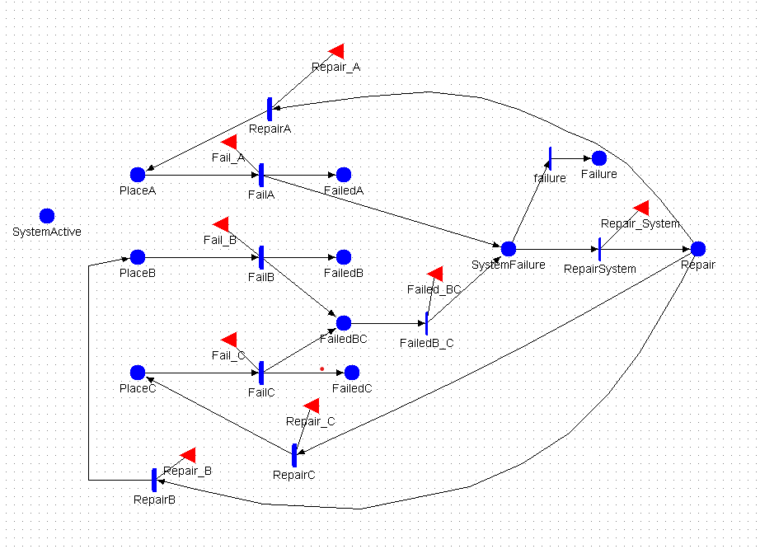

Initial Markings:

* 3 Token in PlaceC
* 2 Token in PlaceB
* 1 Token in PlaceA
* 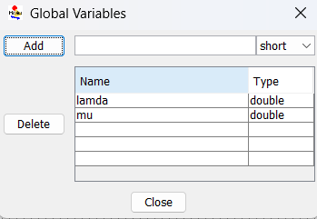1 Token in SystemActive
* 0 Token in other place’s

Rate of Failure Activities:

* PlaceA Failure: lambda*(PlaceA->Mark())/4.0
* PlaceB Failure: lambda*(PlaceB->Mark())/2.0
* PlaceC Failure: lambda*(PlaceC->Mark())

Rate of Repair Activities:

* PlaceA Repair: mu/4.0
* PlaceB Repair: mu/2.0
* PlaceC Repair: mu
* Failure Activity fire, 1 token is removes from PlaceA/B/C, 1 is added to FailedA/B/C, this token consumes when the repairing activity fires. Later token added back to PlaceA/B/C.
* When FailedA have 1 token it directly goes to SystemFailure. And when FailedBC have 2 tokens (1 from FailedB & 1 FailedC) it goes to SystemFailure continuously system will stop working.
* We have a system failure when FailedA fires or when FailedB_C has 5 tokens, after that 1 token is added to Failure_Memory (only the first time), used to calculate Reliability.
* The input gates Repair_ A/B/C allows component repairing only if the places FailedA/B/C contain at least one token, and the units that have a priority no longer have a token in FailedA/B/C.
* Activity Repair gets fired only when FailedA/B/C no longer contains tokens and the repair take place in a sequential order A, B then C.

**Reward Variable:**

**1.Availability** (Steady State Checking)**:** The Reward function return 1 if “SystemWorking” have 1 token.

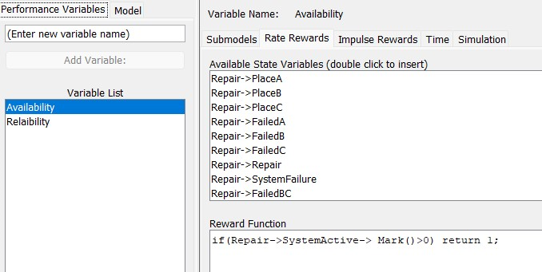

**2.Reliability:** Reward Function return 1 if “Failure” has 1 token. This indicates that system failed at the first time.

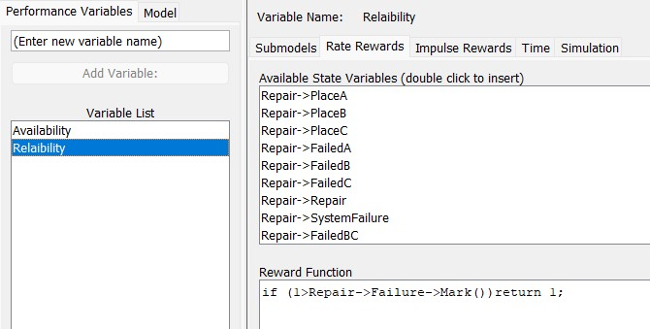

Time Range :

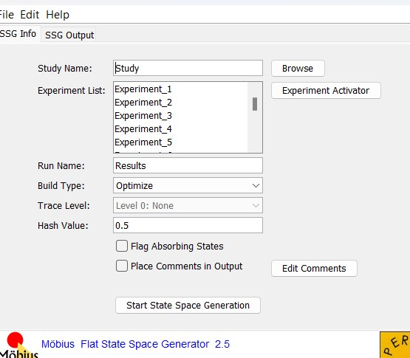**Transformers:**

first run a state-space generator on the model to build a representation of the stochastic process underlying the model and then use a transient solver to compute the measures.

**Study**:

Once we have done with modelling, we need to check the behaviour of the system for different parameter values and number of experiments.

**Transient Solver**:

The transient solver (TRS) solves for instant-of-time variables with t < infinity using randomization. It calculates the mean and variance of each performability variable for the time points defined for the reward variable within the reward model.

# 

# **7.Analysis of System**

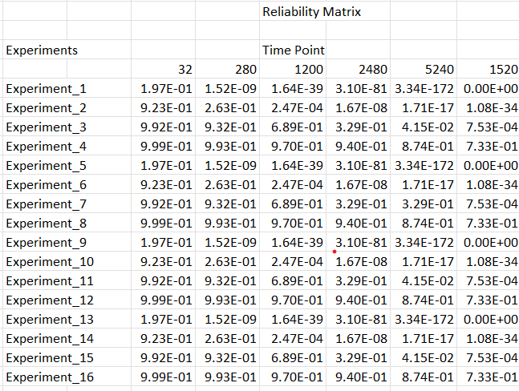**Probability of Continuous Operation**: The probability that the system remains continuously operational in the interval [ 0; t] is influenced by the failure rates 𝜆 and the repair rates μ. As the failure rate decreases (lower values of 𝜆), the system's overall reliability improves. Similarly, higher repair rates (greater values of μ) lead to quicker recovery after a failure. Consequently, by adjusting these parameters, you can enhance the system's continuous operation probability.

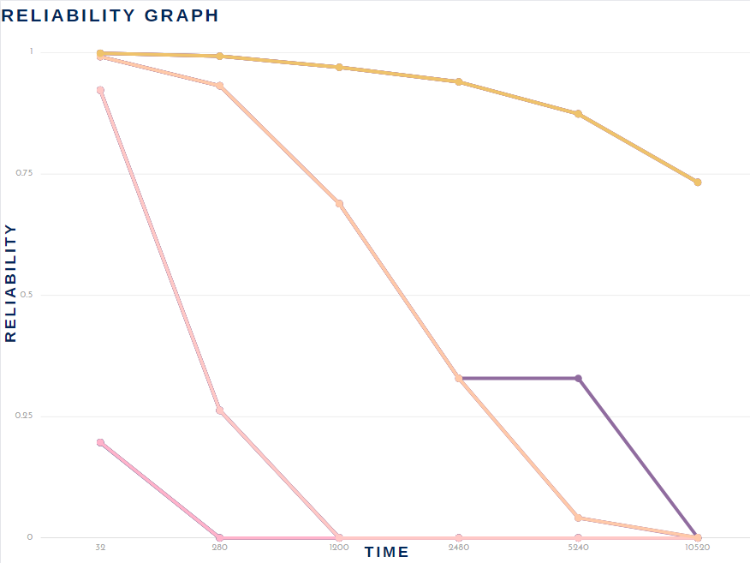

**Steady-State Availability**:

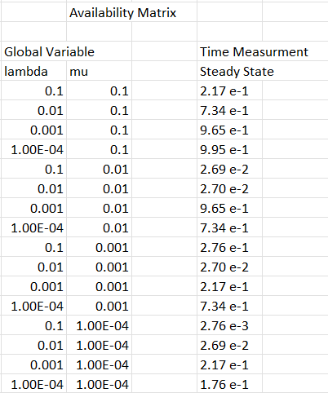 The steady-state availability of the system is a measure of how often the system is operational over the long term. It accounts for both failures and repairs. In this scenario, since repairs are carried out sequentially after a total system failure, the steady-state availability is determined by the sum of the operational times and the repair times. As the failure rates decrease and the repair rates increase, the steady-state availability of the system improves, indicating better overall system reliability and readiness.

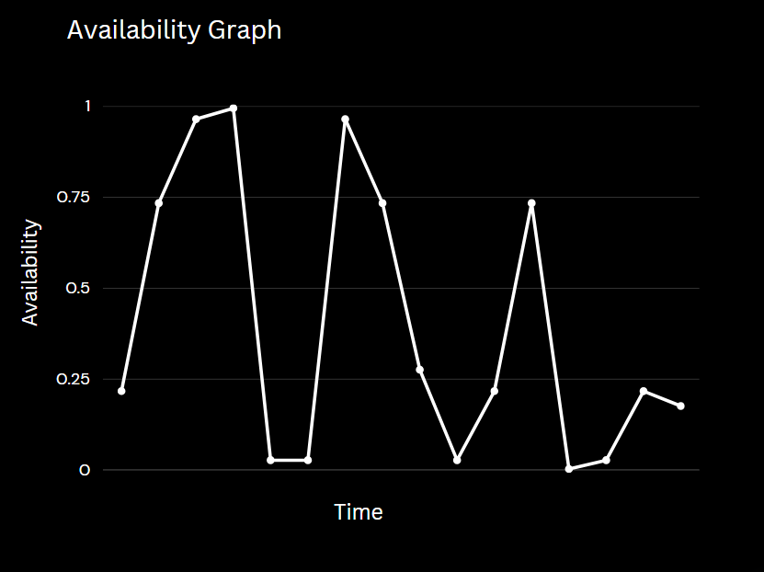

**Conclusion**

We evaluated the reliability of a critical system under the unique conditions of Options R1, O1, and W1 during this project. In this case, we focused on restoring the system one step at a time, beginning with A, then B1, B2, and lastly C1, C2, and C3. It should be noted that repairs could only begin if the entire system failed, and the system would restart operating once a path between its source and destination was restored.

These findings highlight the need of designing systems with efficient repair strategies and considering the relation between failure and repair rates in order to improve overall system dependability and availability.

In conclusion, this project shows the importance of careful system design and repair planning. It highlights the importance of dependable systems in today's society and how dependability analysis helps to ensure their success. This project's results not only improve our academic understanding but also help us better manage and improve the systems that support our society. This effort shows how theory and practical implementation may improve the way we interact directly.